Operation Research Meta Heuristic Report

1st try :Temperature =100,no of iteration =100

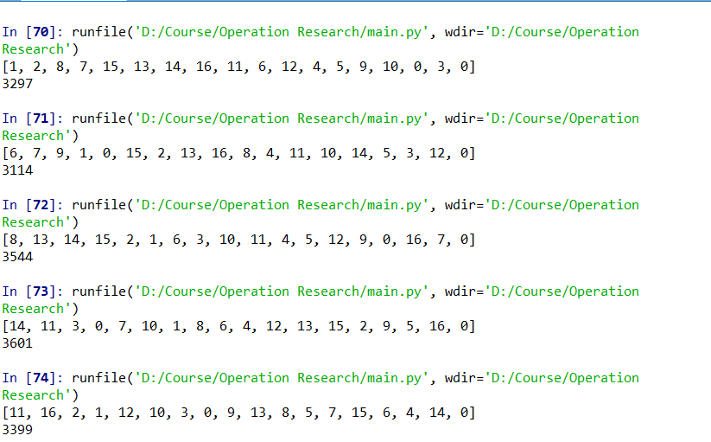

The result seems acceptable but after some try

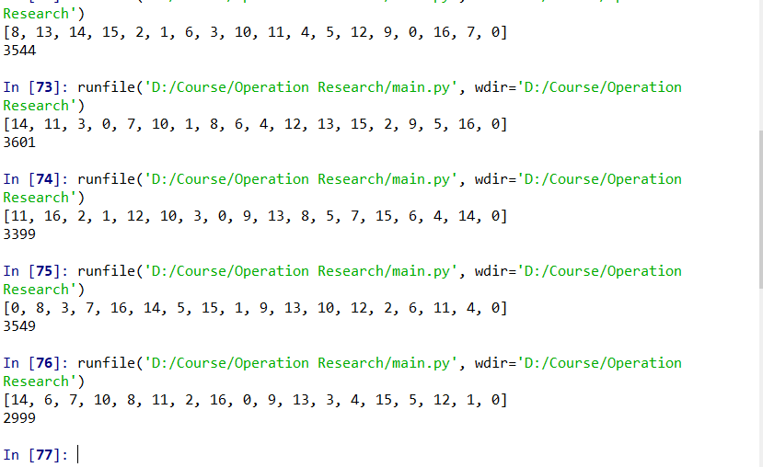

The local optimal solution become 2999,which is much less than the solution we get before (3601).Looks like the number of iteration is too low.

2nd try : Increase the temperature in order to increase the hopping

probability .Increase the number of iteration

Temperature =200

No of iteration =10000

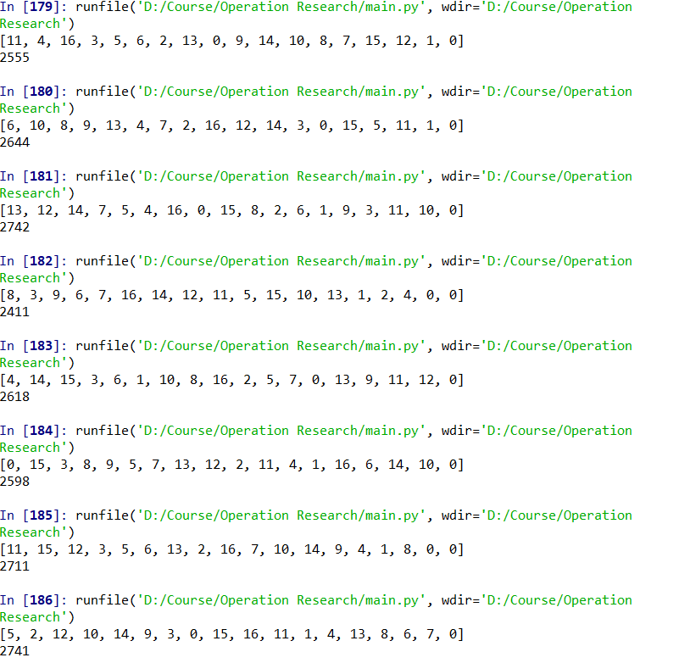

The result is much better than the initial try

3rd : Try to further increase temperature

Temperature =700

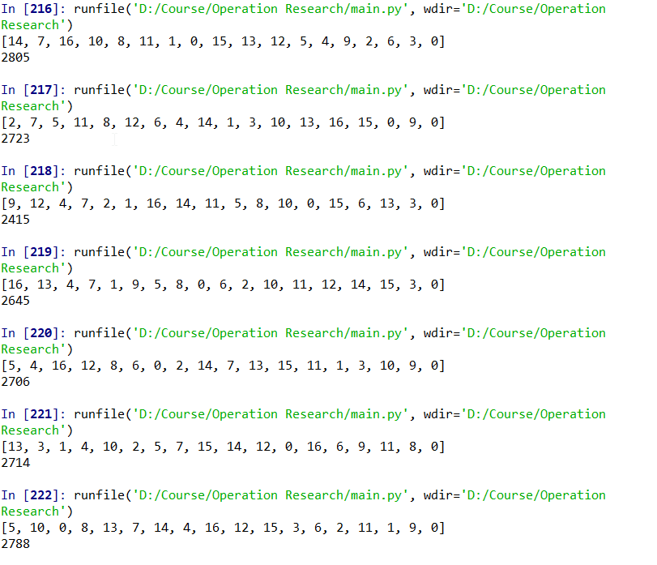

We can get best solution (2415) although the difference between each solution is much higher

FINAL ANSWER

approximate optimal solution:

9->12->4->7->2->1->16->14->11->5->8->10->0->15->6->13->3->0

fitness function value:

2415

Running time :

1.1009202003479004 seconds